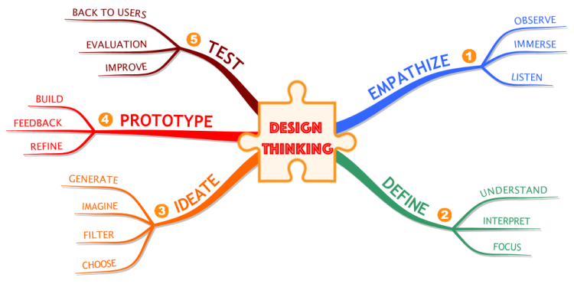2.**2 Ideation & Brainstorming Map**